
Advanced Database
[Document subtitle]
Lyubo Brankov | [Date] | [Course title]

Link to my GitRepository
https://github.com/lbz21/Advanced-Database-Project

Advanced Database and Systems

Introduction to the requirements of my full-stack web application
Аs part of our of building a full-stack web, and database application, we were instructed to base our application on а real-world problem, or a problem in our work life, or in our personal life’s. To be more clear, the application should either help make sense of already existing datasets, or just like I previously wrote, help solve a real-world problem. The main and most important aspect of the how deployment was to demonstrate CRUD (Create, read, and update), especially in the part, where we are creating our database to store any type of datasets, into the MongoDB platform.

Choosing the right topic of my web-application
When it came to choosing an appropriate topic, related to a problem in my life or life at work, I had a few ideas on my mind, but the best one I could come up with was “the problem with time management” as this is the most relatable problem that I could think of that affects a lot of individual’s life both personal, and work, and speaking personally this is a really relatable problem that has caused a number of disturbances in my life, work and university. Overall, I do think choosing to base my web application, and all information containing on this well-known problem, would cover the main requirement for “helping me to solve a real-life problem” just like required to. The main purpose of creating this application is to eventually make the users, and the target audiences, which from my understanding I imagine they will most likely be students, and office workers, just overall people who might struggle to manage their time well, especially during those long COVID-19 times of uncertainties, and bad expectations. This is what mainly inspired me to create a web-application focusing on the problem with the “Time management” .
Furthermore, to fully back up my reasons as to why the chosen topic for my full-stack web-application is a reasonable topic to focus on, and perhaps come up with methods to help some people manage this potential problem, and I have made a few researchers, and managed to find some really useful statistics and a few survey results, plus some additional facts and figures to fully support my ideas of how big the problem with the management actually is. From what I found out in some of the useful sources about time-management problems are statistics that strongly reinforce my views on how huge the negative impact on bad time-management actually is, and these are statistics, which I will be citing in my website as they are really useful. From what I found out on https://www.dovico.com/blog/2018/03/06/time-management-facts-figures/ is that “The average person gets 1 interruption every 8 minutes, or approximately 7 an hour, or 50–60 per day. The average interruption takes 5 minutes, totalling about 4 hours or 50% of the average workday. 80% of those interruptions are typically rated as “little value” or “no value” creating approximately 3 hours of wasted time per day.” And also “It takes approximately 30 days to establish a new physical or emotional habit.”
As you can see I have left a link to the website where I made some research in order to decide if my topic is really appropriate, and to also use statistics for my website to what is called “making an awareness”, and I will be using those statistics for my website. I also think that statistics are a good indicator of showing how serious bad time-management can be, and to some extent support my argument for the topic.

System Overview
Web-based front-facing interface.
In the requirement brief, it was specified that our web application should be full-stack( have both front-end, and back-end functions and interface), and include either a non-relational database or a relational database that demonstrates CRUD (create, read, and update). The front-end part of my web-application contains the following: Five different html files, including a “home” page, Javascript, and MyCSS personal stylesheet. For my front-end I’m fully using a bootstrap scheme to implement and organize the structure of my front-end content.
To implement the colours, and fonts for all my contents, I have also decided to use a bootstrap link. The only exception made, where I have created personal CSS stylesheets are the last few index files that contain a feedback/contact form and register form because I wanted to again put in practise some front-end skills and also improve the display and margin of my two forms, and therefore my navigation bar will positing vertical instead. Last but not least, in order to show some form of interaction, and to make my front-end look more user-friendly, I decided to implement some scripting language, mostly for my two forms as I thought that just there, I had the opportunity to demonstrate my scripting skills.
Database implementation and design
When it comes to the back-end section, I decided to implement a non-relational type of database to store the user’s information from my Feedback form in a MongoDB Atlas Cluster, using the mongoose connection method. I decided to implement all my back-end functions for creating and deploying my database, in a single node file, because like that I will be able to control everything from there. In the “database design” section there will be description of the structure of datastore. The key differences between a relational type of database, and my database is that relational are stored in either multiple tables, while the non-relational, which in my case is MongoDB, a JSON file must be defined and the purpose of this file is to simply structure my data into what is known as document.
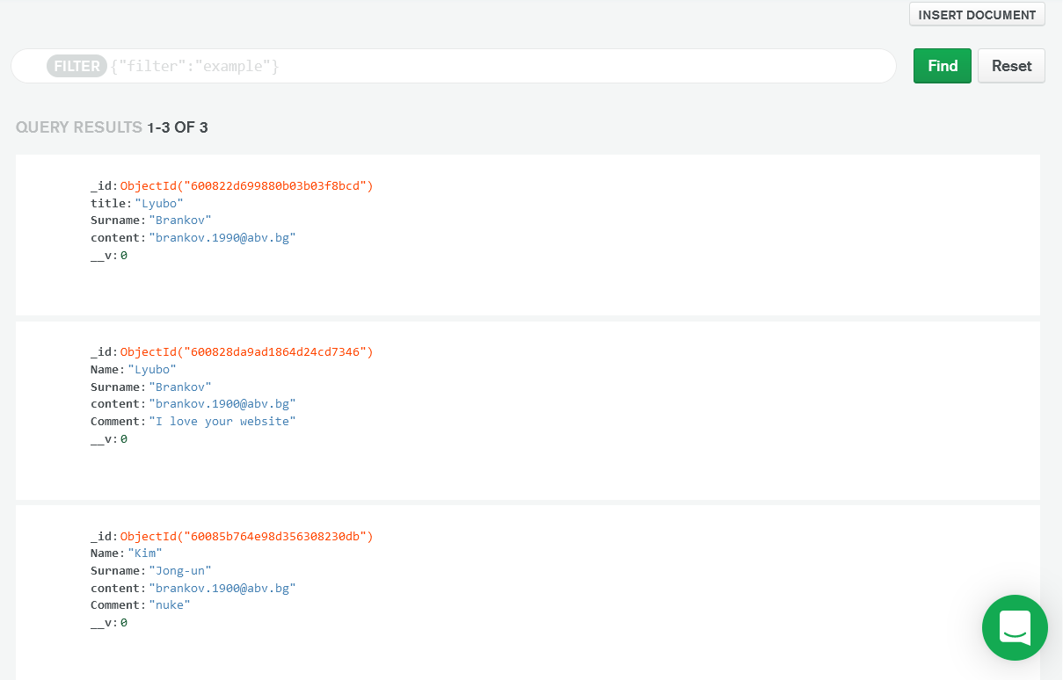

Why did I choose non-relational database MongoDB over SQL?
Just like I have already stated, in the section “Web-based front-facing interface”, my web application will have a single page, where there will be a feedback form, where the user will have the perfect opportunity of expressing his views, both positive and negative, on how effective the information within my website is. This comes of great use to me personally, as I will be able to know how good my content is, and are there are rooms for improvement that I can make for the future. However, for this purpose, I need to obviously have somewhere to store this feedback, alongside with the details of the user, the author of the specific feedback, and for this purpose I need to have either a local database server, or to be able to connect remotely to my chosen database.

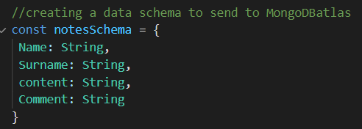
Caption: Noteschema document

I have decided to store the information that the user has inputted, when giving a feedback in a remote type of database – MongoDB atlas in a form of schema called notesSchema. The details that I will be storing are the name of the user, the surname of the user, the email (for the purpose of getting in contact with him, for things like future events, and other important information, and changes within my web application) Just like already stated, in order to be able to store all the details that I’m planning to store into my remote database, JSON-like documents will need to be one of the essentials needed to store the data already mentioned. Another good reason as to why the JSON-like documents are required is because they come with a great offer of flexible and dynamic schemas, just like the one I have created. The data of the data stored will be updated and fully managed in the MongoDB Atlas. In my opinion the MongoDB Atlas was a better choice than just storing the user’s data locally because the MongoDB is classified as cloud database storage, created, and maintained by the MongoDB team. The MongoDB atlas has all the features of the MongoDB, including the CRUD (Create, read, and update) operations, which in my opinion makes it one of the most suitable NoSql database. Not only that, but MongoDB Atlas improves performance, availability and security. Another good argument as to why I came to this choice.

Technology used to create/connect the database with my design.
The technology used to connect my feedback/contact us form to my MongoDB cluster database is fully back-end code.

Key features of my design, and interfaces
Throught the NodeJS server application of my database, I have used a number of interfaces. Without making an interaction, the system application would not be able to function as it should. One example of an interface connection, or what in my case would be an interaction between the back-end and the front end, client side, would be the request, and respond methods that I have implemented in order to examine any form of actions or interactions from the client-side of my full-stack application – in my case, the feedback form. The request and response methods are also one of the very key features of my application, responsible for the actions and performance.
Another really vital feature of my design is the “method=post”,(defined in my html form) so the information of the user can be posted into my server, and then into the MongoDB atlas.
Post method
The way I have implemented the interfaces of my application design are not any different to how the description of the whole process of handling information. То fully complete the interface for my design, the first thing I did is I provided a name for each input of my form, for example name=name, so the body-parser is able to take the value of for example the user’s name or surname, through the reference to for example name=surname. In this case, what is known as the the app.post request, will use a req and res functions, and therefore my req.body.name will communicate with the method in HTML, through my body-parser. The req.body will also allow me to access any form of information that is a String type, which in my case is the whole HTML form information. I will be using the req.body object to receive the data from my form through a POST, and send a request to my express server.
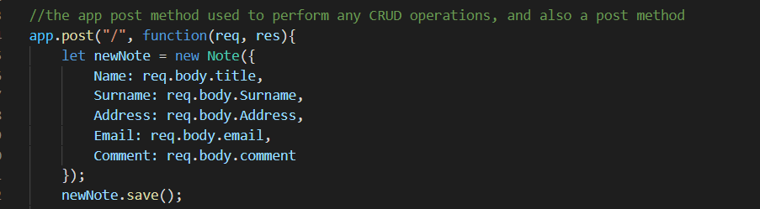

Another key feature, which I also consider as a key interface would be the environment variable method, known as the “dirname”. This is a variable that simply will return the directory name of the path I have chosen, which in my case is the HTML File. Basically, the purpose of this method is to render my HTML form file, and to specify the location of the file.
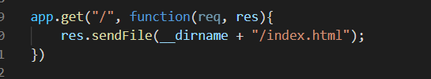

Data schema
To store my data into MongoDB Atlas, I have created a document, which is called notesSchema, and this document form will hold the details of the user in a form of string, which will be sent, updated, and modified in the MongoDB database cluster. In the next section, I have further described how I specified my connection to the database.

Method/s used to connect to the database
In order to store my data, and to create a connection between my server and Atlas, I decided the mongoose is the right choice to establish a connection. Below there is a diagram describing this process.
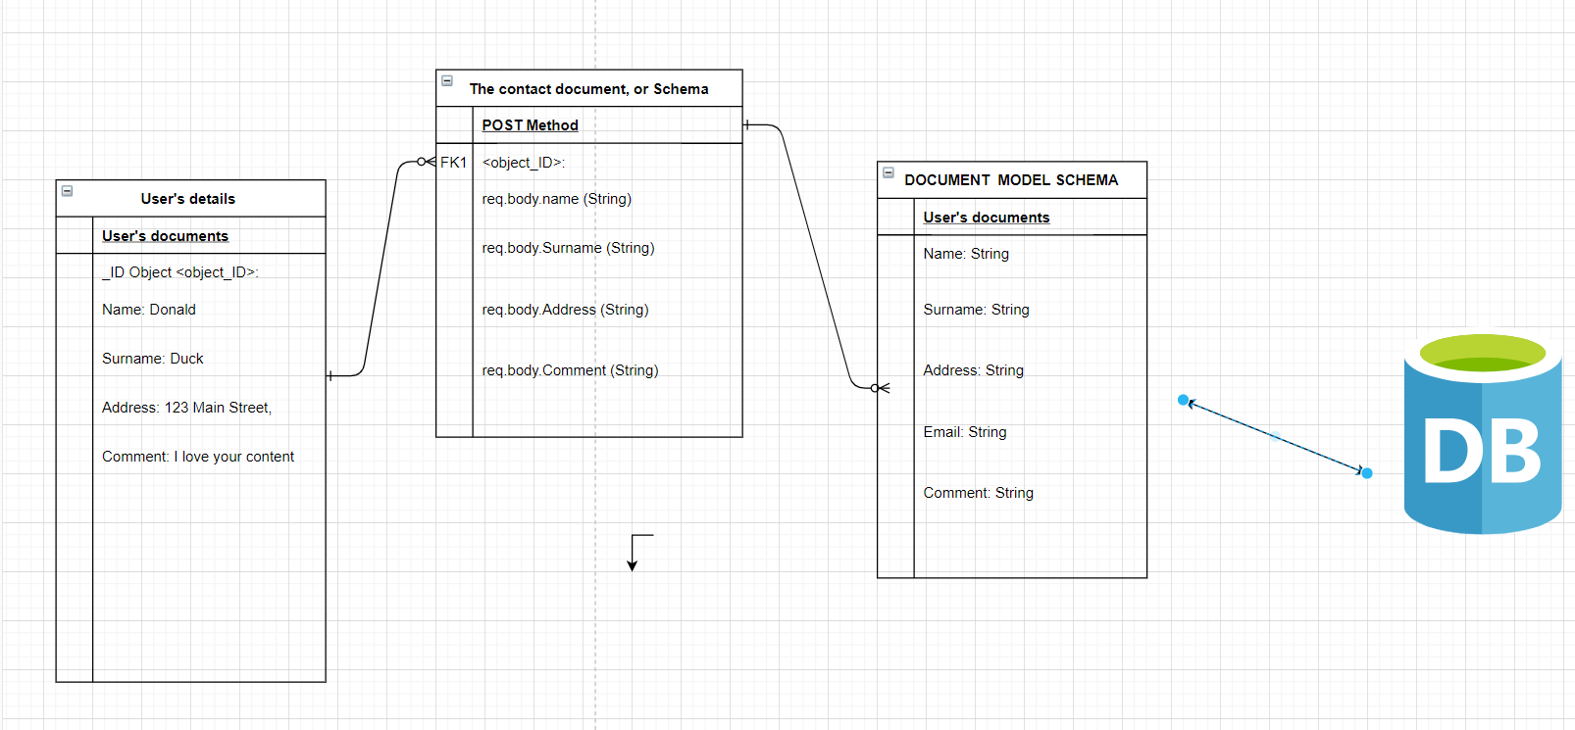

Key Design Decisions
One of the few choices I had to make was whether to implement a non-relational type of database or a relational type of database. At the end I came to the decision that the best choice would be to create a non-relational database, which is obviously my feedback form. One of the reason as to why I came to the decision to implement only one non-relational database for my web application is because from the researches that I have made on https://social-annotations-development.web.app/week-5?fbclid=IwAR3g8K7McxKT9zHtOhYsvsZy_gj1KoBfkpc5GYN5CWoRgWDNiklTmnOSntE#task-1-30-mins , and some other websites, I have found out that the non-relational type of databases tend to demonstrate faster performance as the query does not have to view other tables in order to come up with an answer. Also, a good argument that I can also come up with to support my opinion is that the non-relational databases are more easily changed, compared to the relational databases. This again comes of great benefit to me as I will be storing a data of many users, and I’m aware that this type of database requires frequent monitoring, and a lot of maintenance.
Security and Scalability
MongoDB Atlas provides high level security. Security level is really important as I will be storing the user’s personal details in my database.
On https://www.mongodb.com/cloud/atlas/security I have found that the MongoDB Atlas “offers built-in security controls for your data”, and that “MongoDB Atlas dedicated clusters are deployed in a unique Virtual Private Cloud (VPC) with dedicated firewalls. Access must be granted by an IP access list or VPC Peering.” And there it was up to me to guarantee a high-security level for the user, so what I did is I made sure that the database can be accesses only from my IP. Therefore, only I personally will be able to edit, and view the document in the cluster collection.
Scalability
When it comes to scalability, I would think that my application meets the scalability requirements to a certain extent. I have made sure not to include any unreliable information, and non-vital. As far as I was informed, the MongoDB Atlas has the feature known as Auto-scaling. My collection size is 490B, and the Indexes Total Size:
36KB.
Conclusion and Reflection
When it comes to concluding and reflecting on how effective the chosen topic, and the implementation of design were quite effective, and meet the requirements. I did manage to design, test, and deploy, a proof of concept data-driven full stack web-application Firstly, I am really satisfied with the topic that I have chosen for my web-application, and also the way I have implemented it all in the front-end. The client-side part of my website reveals many facts, from either a research made from some external sources, which help the user to get more familiar with the existing problem of the “poor-time management” and how that has changed our lives.
I think that the proposed solutions to that problems included within the content of my website are effective, and that my content is well structured, which makes the client-side of the website user-friendly, and readable. When it comes to how effective my website was when it came to helping people solve problems with the time-management, I do think this came out really good. On two of my front-end pages, I included a whole section of why and how to solve the problem with evidences from sources that I have already cited.
Also, I do think I was quite successful with my back-end. I feel like I I managed to show a good reflection on what I learned about the types of databases, and how to implement the NodeJS. Also, I managed to at the same time get get more “hands on approach” with the NodeJs, but I did encounter some problems. One of the problems I had was the setting up of a localhost, as I did not have some of the functions for that operation installed – for example “express” but then again thanks from those mistakes I was able to learn what went wrong and how to fix it for the future, and to reflect on what I have learned I decided to further explore the foundations of the NodeJs, and how mongoose works to establish connection between the server, and the MongoDB database. One of the things that went unexpected with creating my design was connecting my register form to the MongoDB database, as I encountered some file conflicts and many errors. My plan originally was to store details like password in my database, and emails, using register form. Instead the user will provide his email in the feedback form, so he can receive news, etc.

